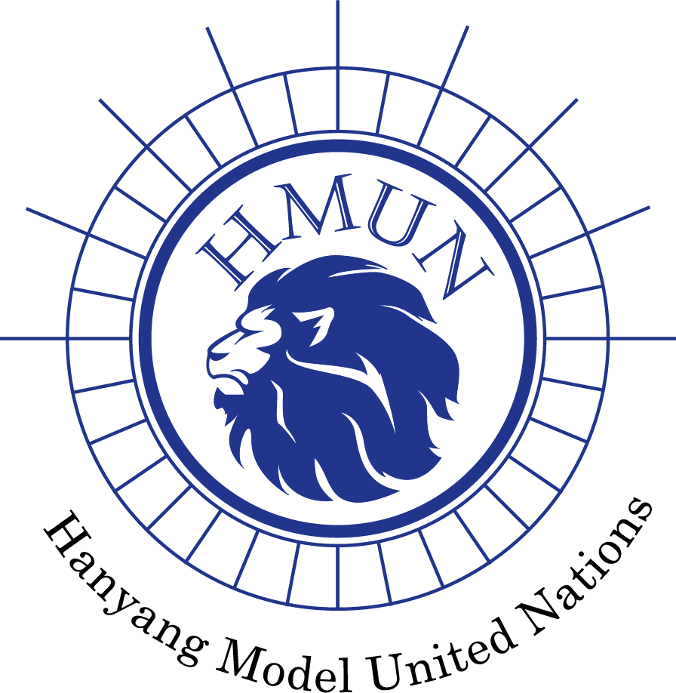
Hanyang Model United Nations VI Chair Report

Committee: United Nations Security Council (UNSC)
Chairs: Angelyn Nichole, Yoon Seo Choi
Agenda: Devising Measures to Facilitate Democracy and Peace in Myanmar

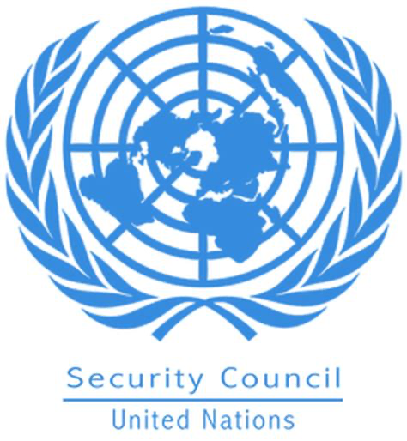
1. Committee Introduction
The United Nations Security Council was established after World War II, in accordance with the provisions of the UN Charter. It was founded in response to the horrors of war and the recognition of the need for a global collective body to prevent such devastating conflicts in the future. The United Nations Security Council (UNSC) succeeded the League of Nations, and its founding members sought to learn from the shortcomings of its predecessor.
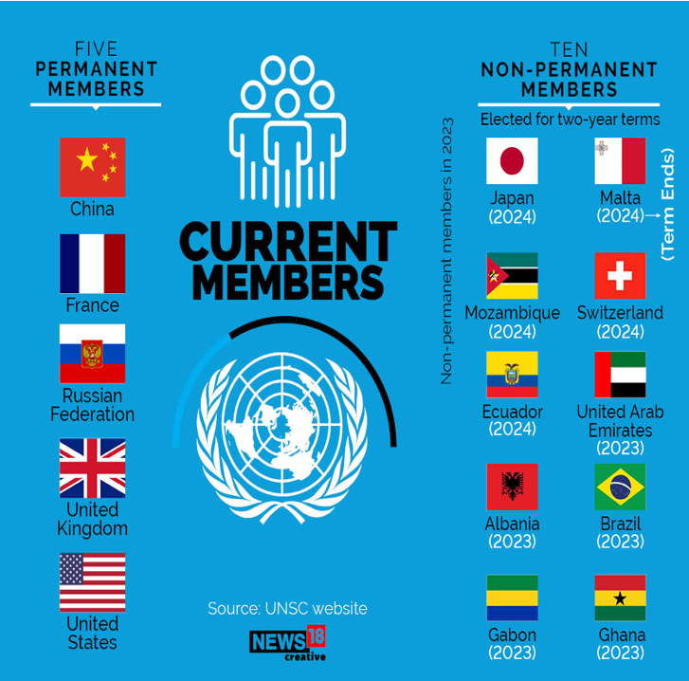
The UN Security Council has 15 members, five of which are permanent members, known as the P5 - China, France, Russian Federation, the United Kingdom, and the United States. These permanent members have veto power, allowing them to veto any substantive resolution, making Council dynamics complex and significant. The remaining ten seats are filled by rotating members elected for two-year terms from various regional groups. Currently, those seats are filled by Albania, Japan, Malta, Mozambique, Switzerland, Ecuador, United Arab Emirates, Brazil, Gabon, and Ghana (United Nations Security Council, n.d.).

The primary mission of the UN Security Council is to maintain international peace and security. It is given the authority to act on a wide range of issues, including the deployment of peacekeeping missions, the imposition of sanctions, and the authorization of military force to restore or enforce peace. The decisions of the UN Security Council are binding on all UN Member States, making it a powerful and unique international institution. According to the UN Charter, any state involved in a conflict, whether or not it is a member of the UN, may bring it to the attention of the Security Council. When a complaint is filed, the council's first step is to look into the possibility of a peaceful resolution. In some cases, the council may authorize the deployment of foreign peacekeeping forces to keep warring parties apart while further negotiations take place. If the council determines that there is a genuine threat to peace, a violation of the peace, or an act of aggression (as defined in UN Charter Article 39), it may request that UN members impose diplomatic or economic sanctions. If these measures are ineffective, the UN Charter authorizes the Security Council to take military action against the offending state (United Nations Security Council, n.d.).
The UN Security Council has played a critical role in addressing numerous global crises, conflicts, and humanitarian emergencies since its inception. The Council's agenda has evolved to meet the changing nature of global threats, from the Korean War in the early 1950s to more recent challenges in Syria, Ukraine, and climate change. To ensure that its responsibilities are met, the Security Council works with various committees. The Military Staff Committee, for example, aids in the coordination of military activity by UN members in accordance with council resolutions. There are also Sanctions Committees for each UN-sanctioned state, Peacekeeping Forces Committees in charge of overseeing UN peacekeeping forces, and an International Tribunals Committee that works to support the work of international criminal tribunals.

2. Agenda Background
a. General Election and Military Coup D’état of Min Aung Hlaing
Protests in Myanmar, known as the ‘Spring Revolution’ locally, started with military coup of Min Aung Hlaing, on 1st February 2021. In 2010 Myanmar went through a phased democratization process, which enabled parties like NLD(National League for Democracy) to be legalized in 2012. In 2015 general election NLD leaded by Aung San Suu Kyi had overwhelming victory by winning 88% of possible seats and established a civilian government. However, influence of the former stratocracy was still strong. For instance, the USDP(Union Solidarity and Development Party) was one of the prevalent pro-military parties, and some members of Tatmadaw, which is the currently active military of Myanmar administered by the Ministry of Defence and composed of Myanmar Army, Navy, and Air Force, were even have previously belonged to Coup armies. Since the constitution of Myanmar recognizes military’s influence on politics and the military owns the actual power regarding security, there always existed concerns about military coup.

In November general election in 2020, citizens of Myanmar showed strong will to move the country’s democratic reforms forward. More than 70% of the country’s eligible voters cast their ballots. (Figure below, Myanmar’s 2020 General Election Results in Numbers, The Irrawaddy) The military coup d’état occurred the day before the Parliament of Myanmar was supposed to swear in the members elected at the November general election. elected representatives from the November 2020 elections refused to acknowledge the coup's legitimacy. Around 70 members-elect of the National League for Democracy (NLD) pledged to serve their five-year term as lawmakers in February 2021. CRPH condemned the coup as a "criminal act" on February 7, 2021, and dismissed Min Aung Hlaing's military cabinet as illegitimate. They urged UN diplomats and the international community to engage with them for official government matters. Various ethnic groups and political parties voiced support for ongoing protests and the return of civilian-led government while condemning the coup.

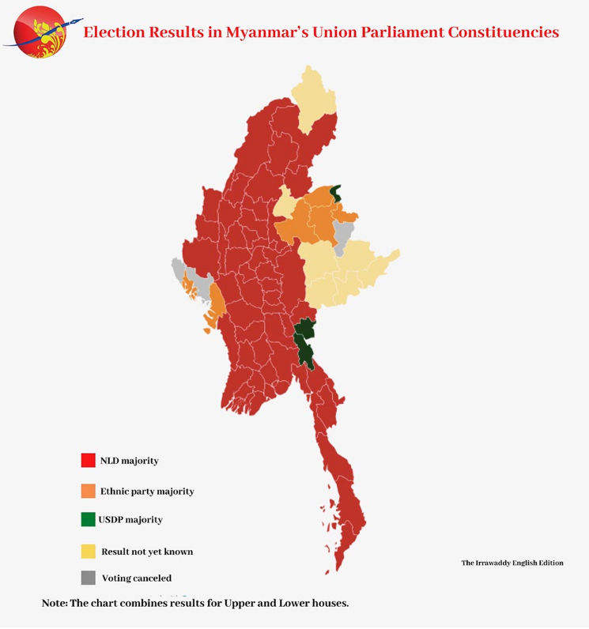

b. Civil Disobedience Movement and Labor Strikes in various areas
On February 2, 2021, healthcare professionals and civil servants, including those in the national capital Naypyidaw, initiated a nationwide civil disobedience movement in opposition to the coup d'état. This movement, known as the "Civil Disobedience Movement," gained substantial traction on Facebook, amassing over 230,000 followers since its launch on the same day. The movement spread further to healthcare workers in state-run hospitals, institutions, and healthcare agencies. Since Myanmar was under COVID pandemic situation, those movements were critical. Even the participants of the movement faced threats from the superiors, by 9 February, COVID vaccination was postponed and most of the hospitals in Myanmar shut down. (Myanmar Medical Workers Join Civil Disobedience Movement Against Military, RFA)
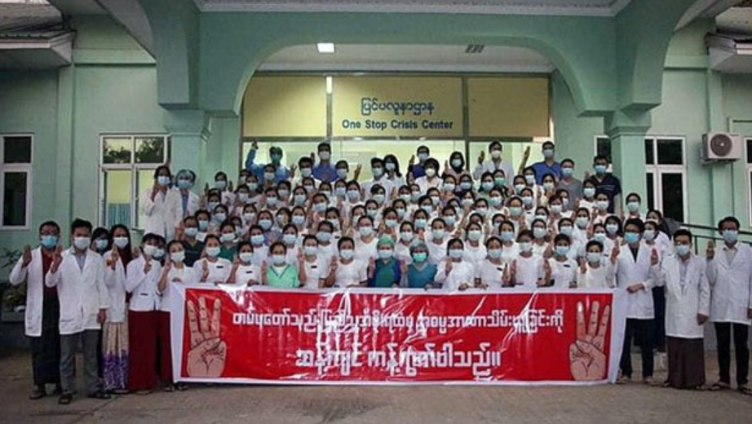
The labour strike was not limited in the medical sector. It also spread to education, administration, mining, railway sectors and further to universities. Seven organisations of teachers promised to join the labour strike, including Myanmar Teachers’ Federation. (Teachers, Students Join Anti-Coup Campaign as Hospital Staff Stop Work, Frontier Myanmar) By 5 February 2021, the civil service labour strike included workers and students of “91 government hospitals, 18 universities and colleges and 12 government departments in 79 townships”. (Thousands Join Peaceful Protests in Myanmar Against Military, The Irrawaddy) On February 11th, Min Aung Hlaing called upon civil servants to set aside their emotions and resume their duties. In a different development, on February 16th, a spokesperson from the Ministry of Information cautioned civil servants who were involved in the movement, emphasizing that authorities wouldn't wait much longer for their return to work. From 25 February, truck drivers also joint the strike by rejecting to transport goods from the docks at Yangon’s main ports, promising to transport only essential food, medicine, and fabrics for factories. (Containers Pile Up at Myanmar Ports as Coup Protests Snarl Trade, Daily Maverick)

There were several more movements other than labour strikes, too. On 2 February 2021, “Stop Buying Junta Business” campaign started, which called for a domestic boycott of goods and services attached to Myanmar military. Among the targeted products in the military’s significant business portfolio included Mytel, a national telecoms carrier, Myanmar and Mandalay Beer, several coffee and tea brands and also 7th Sense Creation, whose co-founder is the daughter of Min Aung Hlaing. There also was a pot-banging movement, where citizens in urban areas made noises by banging their utensils and the “Red Ribbon” campaign launched by healthcare workers starting on 3 February 2021. Since the color red is associated to the National League for Democracy (NLD), the red ribbon was used to symbolize the opposition to military regime by various civilians. In the morning of 5 February 2021, “around 500 staff across five ministries in Nay Pyi Taw stopped work briefly to take photographs of themselves wearing red ribbons”. (NLD Backs Anti-Coup Campaign as Civil Servants Rally in Nay Pyi Taw, Frontier Myanmar) Meanwhile, the movement against military regime was backed up by social media where celebrities and influencers demonstrated their support for the protests. Netizens also made popular hashtags like #SayNototheCoup, #RespectOurVotes, #SaveMyanmar and etc. Within a day after the coup d’état, the #SaveMyanmar hashtag has been used by over 325,000 users in Facebook. (Coup Sparks Outcry on Myanmar Social Media as West Ponders Next Step, The Japan Times)

c. Repression Towards the Protests by the Military Regime
First there was an internet outage by the military authorities to prevent civilians to access their social media. It first started from 4 February 2021, when telecom operators and internet service providers were demanded to block Facebook which played a huge role to organise civil disobedience, labour strikes and other movements until 7 February in the purpose of “ensuring country’s stability”. MPT, Myanmar Posts and Telecommunications, additionally blocked Instagram and WhatsApp services and the governmental prohibition of social media access stretched lastly to Twitter. Finally starting on 15 February 2021, the official internet outage was enforced across the nation from 1 a.m. to 9 a.m. everyday. (Military Imposes Full Grip on Myanmar in Overnight Crackdown, The New York Times)

Not only media blackout but also force was used by the military to put out a civilian movements. Many people were arrested including university students for protesting, a school principal for taking part of “red ribbon” campaign in her school, and even political figures of opposition parties like Maung Gyi, the chair of the United Nationalities Democratic Party and Win Htein, the leader of National League for Democracy. Aung San Suu Kyi, the iconic figure symbolizing democracy, was also driven out and imprisoned by the military with the sentence of 33 years in jail. On 2 April 2021, eleven individuals were detained in Yangon after answering the interview from CNN television crew(Myanmar Junta Now Publishing Lists of Wanted Journalists, RSF) and on 6 February 2021, the Australian economic advisor of NLD-led civilian government Sean Turnell was also detained, showing the high sensitivity and initiative of the military against its oppositions. (Myanmar detains Australian adviser to Aung San Suu Kyi; first known arrest of foreign national since coup, Channel NewsAsia)

The most notable point of the situation is that the military is using violence against civilians practicing non-violent protests including civilians with no relations. Based on information provided by the AAPP, as of January 3, 2023, a total of 2,692 demonstrators have lost their lives. (Assistance Association for Political Prisoners) The military junta's reckless application of violence has tragically claimed the lives of at least 44 young individuals, which includes a incident involving a 7-year-old girl who was fatally shot inside her own residence. Starting from February 8, 2021, law enforcement authorities initiated the deployment of rubber bullets, water cannons, and tear gas as means to scatter demonstrators participating in large-scale gatherings. As of April 11th, the AAPP reported that the nation has exceeded 700 fatalities since the commencement of the protests. There is growing armed repression against protesters and civilian armed resistance force.

d. Ongoing Protests and Ethnic Resistance Force
On February 1, 2022, in commemoration of the first anniversary of the military coup, the people of Myanmar engaged in a "silent strike" by remaining at home, shutting down businesses, and ceasing all outdoor activities. This led to the streets in numerous major towns and cities becoming largely empty. The military junta issued warnings that those participating in the strike could face charges under terrorism and incitement laws. (A Year After Coup, Myanmar Is Mired in Conflict and Chaos, The New York Times)

Meanwhile, Myanmar has experienced insurgencies continuously since 1948, when the nation, previously referred to as Burma, achieved independence from the United Kingdom. These insurgencies were predominantly related to ethnic divisions, involving some ethnic armed organizations striving for self-determination and therefore engaging in confrontations with Myanmar's military, the Tatmadaw. The goal of those ethnic armed organizations, EAO, is to represent their ethnic identities and earn valid recognition of the identities by other EAOs through alliances or coalitions. So Myanmar is previously under civil wars between EAOs and Tatmadaw, which were upsized as some EAOs joined the protests and armed resistance movement. Alongside the movement, civilian protesters joined EAOs to train themselves for armed confrontation with military coup which elevated the risk of civil wars at rural areas of Myanmar. The civilian government-in-exile has proposed the development of a “federal armed force” to fight against the military. Seven of the entities that signed the Nationwide Ceasefire Agreement on April 4, 2021, declared their decision to become part of the National Unity Government, with inclusion of the All Burma Student Democratic Front and the Karen National Union. There were already clashes between EAOs including Myanmar protesters and the military and currently in 2021, The Communist Party of Burma has reequipped and declared the establishment of its new military branch, known as the People's Liberation Army. There exists growing armed clashes and repression against the ethnic minorities who are willing to be recognized their identities socially and politically which is not a desirable state regarding basic human rights and also democracy, which is one of the values the United Nations pursue and protect. As the conflict between EAOs, protesters, and the military is deepening, there is a demand to resolve this urgent situation quickly and peacefully before losing more lives.

Regarding labour rights and freedom of citizens, the UN’s International Labour Organization launched a commission inquiry in Myanmar, and found out “that the military has imposed wide-reaching restrictions on basic civil liberties and trade union rights since seizing power”. (Myanmar Army Making Extensive Use of Forced Labor, UN Probe Finds, Myanmar Now) Meanwhile, Aung San Suu Kyi’s jail sentence has converted to house arrestment, but very little is known about her safety. According to latest statistics of AAPP, total 25,248 people are under arrest, 19,661 people are still detained including sentenced, 4,141 people have been killed by Junta, and 5,587 people have been released. (AAPP, Assistance Association for Political Prisoners)

3. Previous Actions
a. United Nations Security Council
The UN Security Council is the strongest institution in UN whose decisions need to be carried out into actions by member countries of UN according to the Charter of the United Nations.
On 21 December 2022, UNSC adopted Resolution 2669 urging Myanmar military government to stop violence and release detained political authorities including Aung San Suu Kyi. 12 member countries of UNSC voted for and 3 member countries – People’s Republic of China, Russian Federation, Republic of India – abstained their votes. UNSC “reiterates its call to uphold democratic institutions and processes and to pursue constructive dialogue and reconciliation in accordance with the will and interests of the people of Myanmar.” It also “calls for concrete and immediate actions to effectively and fully implement ASEAN’s Five-Point Consensus.” (Security Council Resolution 2669 (2022) on the Situation in Myanmar: Too Little, Too Late?, EJIL:Talk!) Despite there being some positive progress made by the adoption of Resolution 2669, the delegate of Myanmar who represents Aung San civilian government urged UNSC to adopt more powerful policy to guarantee the end of crimes committed by the military and the military regime itself.
Meanwhile, recently on 3 August 2023, UNSC has adopted presidential statement addressing conflict-induced food insecurity in situations of armed conflicts. (Security Council Adopts Presidential Statement Addressing Conflict-Induced Food Insecurity in Situations of Armed Conflict, UN Press)

b. United Nations General Assembly
United Nations General Assembly is constituted of all the member countries of United Nations, where they periodically gather and make responsible decisions about the desirable direction of international flow.
On May 17, 2021, the United Nations General Assembly disclosed that Liechtenstein had put forth a proposal in a resolution, urging for the "an immediate suspension" of arms transfers to the Myanmar military junta. This proposal has gained support from the European Union, the United Kingdom, and the United States. South Korea, the only Asian nation to join as a co-sponsor, has also endorsed the resolution, which calls for the military to "terminate the state of emergency" and promptly halt "any acts of violence against peaceful protestors." However, this resolution was postponed because there wasn’t enough support to pass the text, since many countries asked for more time for negotiation. (United Nations vote on Myanmar arms embargo postponed due to lack of support, France24)
On 18 June 2021, the resolution condemning the violence of Myanmar military regime was passed with 119 nations voting for, 1 voting against, and 36 abstentions. The resolution denounced the military repression against peaceful protests and civilian society and urged to release people who are detained by military’s own will and stop limiting the freedom of expression of Myanmar civilians. The resolution of UN General Assembly has notable political importance regarding international society which cannot be overlooked entirely. However, since a resolution of condemnation doesn’t carry legal binding force, the decision itself cannot force countries like People’s Republic of China, Russian Federation, and Republic of India, who mainly provide weapons to Myanmar military regime to stop their provision, it is evaluated as having only moral, ethical validity toward the agenda. (The situation in Myanmar : resolution / adopted by the General Assembly, United Nations Digital Library)

c. Individual Nations’ Statements and Sanctions
Many nations and its authority figures including United States and United Kingdom condemned and denounced the violence committed by Myanmar military junta, and asked to cease armed violence against the demonstrators. There was also a sanction, the economic or diplomatic regulations given to certain country, by several nations.
On 19 April 2021, the European Union extended regulations to 35 individuals and the corporations own by the government, including freezing of asset and travel bans. The United States Federal Reserve also prohibited the transfer of 1 billion dollars held in the Bank, after an attempt of transfer of the funds was made in the name of the Central Bank of Myanmar on 4 February, and the state furthermore declared to suspend all trade engagement under an agreement upon trade and investment made in 2013 on 29 March. In United Kingdom, the British Foreign Secretary Dominic Raab announced economic sanctions on economic corporations of Myanmar, over funding of the military and relation with military authorities on 1 April.
There were also following protests in other countries than Myanmar to support and be in solidarity. It occurred in Thailand, Japan, Singapore, South Korea, United States, Australia, and Malaysia.

4. Possible Actions and Solutions
a. Adopting Resolution condemning military violence
One of the biggest roles of the United Nations Security Council in UN is to make decisions with binging power. As mentioned upward, UNSC has already made a resolution condemning violence committed in Myanmar by military force and urging release of politically authoritative detainees. If UNSC adopts another resolution regarding the situation in Myanmar and urges more concrete and actual change of Myanmar military regime it will remind the military Junta in Myanmar that international society is still paying attention to the issue and also awaken international attention about the issue which might have loose concerns it needs because more than 2 years have passed since the military coup d'état occurred.

b. Economic and Diplomatic Regulations
The Security Council holds the most power in regards to pragmatic action, since it is able to ask the members of the United Nations to impose certain economic or diplomatic regulations toward agreed-upon countries or governments.
On an individual level, a nation can impose economic regulations to another country by prohibiting all or certain amount of import of the country, prohibiting new investment to be made regarding the country, freezing assets within the country belonging to certain figures, organizations and businesses, prohibiting export to the country including financial services, halting subsidies or aid towards the country. It can also choose to impose diplomatic regulations to another country by prohibiting certain figure of the country from entering, quit diplomatic cooperation, stop issuing visas for government employees of the country.
Regulations regarding economy and diplomacy has various and most of the times, powerful routes to encourage the target country to change its attitude. However, those regulations also have possibilities to only merely effect the military regime itself but damage civilian economy more. Also actually imposing those regulations needs concrete and clear diplomatic stance toward the situation of Myanmar. Since some of the member countries of the United Nations showed lukewarm or ambiguous stance toward the situation, drawing a consensus to impose powerful regulation itself can be challenging.

c. Assistance for General Civilians and Refugees of Myanmar
Since the military coup occurred during COVID pandemic and labour strikes also did, there is shortage of various products and services in Myanmar for general civilians, including food, shelter, medical care, and so on. Many of general civilians are joining the protest or joint the protest, which may harden them to obtain these goods and services. Current civil war between the military regime and provisional civilian government intensified various shortages, and also made many people of Myanmar to leave their countries. Assisting civilians in and out Myanmar will help people of Myanmar to restore, prepare strength and stability for future of and over democratization, and empower civilian provisional government to seize the chance to have victory over the military regime.

5. Defining of Key Words
a. Democratization
The shift towards a more democratic political system involves significant political alterations that align with democratic principles. To what extent democratization happens varies regarding economic development, history, culture, and civil society. It is usually related pursuit of higher level of a stable voting procedure, a direct election system, a multiparty system, and division of powers.
b. Military Regime (Military Dictatorship)
A form of autocracy where authority is vested in one or several military officers representing the armed forces.
c. Repression
the act of using force to control someone or something directly or indirectly. For example, using violence to stop certain action is considered as a repression and also indirect usage of force, power, or authority to actually make someone to do nothing but stop certain action is considered as repression.
d. Economic Regulation
Laws or policies enacted by a government to control and shape actions and behaviors of certain individual, related to economic incentives regarding trade, tariff, fees, subsidy, assets, properties, and etc.
e. Diplomatic Regulation
Laws or policies enacted by a government to control and shape actions and behaviors of certain individual, related to diplomatic incentives regarding entry and departure control, visa, cooperation, diplomatic status in international organization, and etc.

6. Key Questions
I. How has the role of the UNSC evolved over the years regarding democratization process of individual countries around the world?
II. How do the dynamics of the UNSC, particularly the interests regarding Myanmar of the member states, impact the overall international stance about Myanmar?
III. How has UNSC reacted about similar violence against civil movement worldwide?
IV. What actions and solutions can the UNSC consider to stop violence of the military government against its civilians?
V. If regulation should be made, to what extent and by which method?
VI. How can the UNSC effectively assist general civilians in need in Myanmar without assisting the military regime?
VII. Is cooperation with the military regime or recognition of the military regime as valid government needed for better negotiation about its attitude towards its civilians?

7. Bibliography
1. Myanmar's 2020 General Election Results in Numbers. (n.d.). The Irrawaddy.
https://www.irrawaddy.com/election-2020/myanmars-2020-general-election-results-numbers.html

2. Amid Coup, Myanmar's NLD Lawmakers Form Committee to Serve Legitimate Parliament. (n.d.). The Irrawaddy.
https://www.irrawaddy.com/news/burma/amid-coup-myanmars-nld-lawmakers-form-committee-serve-legitimate-parliament.html

3. Myanmar Medical Workers Join Civil Disobedience Movement Against Military. (n.d.). Radio Free Asia (RFA).
https://www.rfa.org/english/news/myanmar/health-care-02092021173347.html

4. Teachers, Students Join Anti-Coup Campaign as Hospital Staff Stop Work. (n.d.). Frontier Myanmar.
https://www.frontiermyanmar.net/en/teachers-students-join-anti-coup-campaign-as-hospital-staff-stop-work/

5. Thousands Join Peaceful Protests in Myanmar Against Military. (n.d.). The Irrawaddy.
https://www.irrawaddy.com/news/burma/thousands-join-peaceful-protests-myanmar-military.html

6. Containers Pile Up at Myanmar Ports as Coup Protests Snarl Trade. (2021, February 25). Daily Maverick.
https://www.dailymaverick.co.za/article/2021-02-25-containers-pile-up-at-myanmar-ports-as-coup-protests-snarl-trade/

7. NLD Backs Anti-Coup Campaign as Civil Servants Rally in Nay Pyi Taw. (n.d.). Frontier Myanmar.
https://www.frontiermyanmar.net/en/nld-backs-anti-coup-campaign-as-civil-servants-rally-in-nay-pyi-taw/

8. Coup Sparks Outcry on Myanmar Social Media as West Ponders Next Step. (2021, February 2). The Japan Times.
https://www.japantimes.co.jp/news/2021/02/02/asia-pacific/myanmar-coup-day-2/

9. Military Imposes Full Grip on Myanmar in Overnight Crackdown. (2021, February 14). The New York Times.

https://www.nytimes.com/2021/02/14/world/asia/myanmar-military-crackdown.html

10. Myanmar Junta Now Publishing Lists of Wanted Journalists. (n.d.). Reporters Without Borders (RSF).

https://rsf.org/en/myanmar-junta-now-publishing-lists-wanted-journalists

11. Myanmar detains Australian adviser to Aung San Suu Kyi; first known arrest of foreign national since coup. (2021, February 6). Channel NewsAsia.

https://www.channelnewsasia.com/asia/myanmar-coup-australian-adviser-aung-san-suu-kyi-detained-323801

12. Assistance Association for Political Prisoners (Burma/Myanmar). https://aappb.org/

13. A Year After Coup, Myanmar Is Mired in Conflict and Chaos. (2022, February 1). The New York Times.

https://www.nytimes.com/2022/02/01/world/asia/myanmar-coup-anniversary-sanctions.html

14. Myanmar Army Making Extensive Use of Forced Labor, UN Probe Finds. (2023, October 5). Myanmar Now.

https://myanmar-now.org/en/news/myanmar-army-making-extensive-use-of-forced-labour-un-probe-finds/

15. Security Council Resolution 2669 (2022) on the Situation in Myanmar: Too Little, Too Late? (2023, January 4). EJIL: Talk!.

https://www.ejiltalk.org/security-council-resolution-2669-2022-on-the-situation-in-myanmar-too-little-too-late/

16. The situation in Myanmar : resolution / adopted by the General Assembly. (2021). United Nations Digital Library.

https://digitallibrary.un.org/record/3929594

17. Security Council Adopts Presidential Statement Addressing Conflict-Induced Food Insecurity in Situations of Armed Conflict. (2023, August 3). United Nations Press Releases.

https://press.un.org/en/2023/sc15377.doc.htm

18. United Nations vote on Myanmar arms embargo postponed due to lack of support. (2021, May 18). France24.

https://www.france24.com/en/americas/20210518-united-nations-vote-on-myanmar-arms-embargo-postponed

