Hanyang Model United Nations VI Chair Report

Committee: United Nations Development Programme (UNDP)
Chairs: Hwikyung Lee, Dain Kim
Agenda: Devising Measures to Bridge Digital Divide between MEDCs and LEDCs

1. Committee Introduction
The United Nations Development Programme (UNDP) was founded on November 22nd, 1965 by the United Nations General Assembly. The committee was based on the merging between the United Nations Expanded Programme of Technical Assistance and the United Nations Special Fund. With 170 countries working together, the committee was established with the purpose of addressing the challenges faced by developing countries. UNDP plays an essential part of the United Nations Sustainable Development Group, along with specialized agencies and other bodies in pursuit of the 2030 Agenda for Sustainable Development. To achieve this, the UNDP focuses on working through six signature solutions to poverty and inequality, governance, resilience, environment, energy, and gender equality.

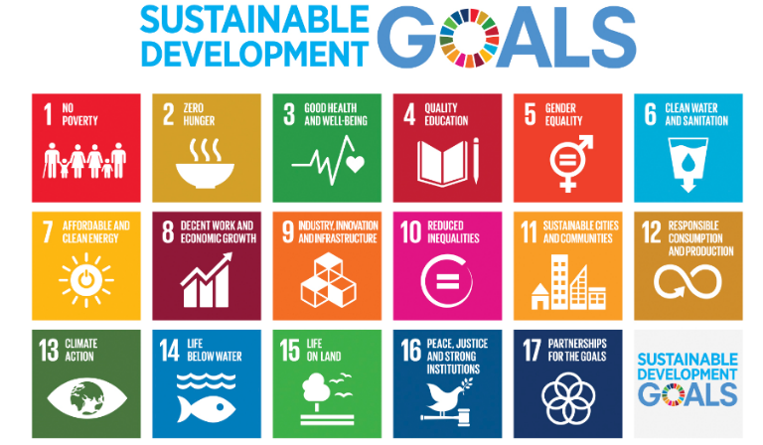

Figure 1 Sustainable Development Goals (source: UNDP)
Ending poverty, establishing democratic governance, the rule of law, and inclusive institutions are all part of UNDP's mandate. The committee’s vision is to promote change and link nations with information, expertise, and resources to assist people in creating better lives. In line with its aim to promote sustainable human development and eradicate poverty worldwide, UNDP’s initiatives have helped people in poor nations better their living conditions, access to basic services, and the economy.
Figure 2 UNDP Policy Center, Seoul, South Korea (source: UNDP)

The Policy Centres, which have offices in Istanbul, Oslo, Seoul, Singapore, Rome, and Doha, perform both policy-making and representational tasks and significantly influence UNDP's practices and policies. Each of the Centers addresses the engagement and policy requirements of UNDP and its partners, providing access to relevant knowledge and connections to outside networks and resources.

2. Agenda Background

Despite over 67% of the population having access to the digital world as of July 2023 (International Telecommunication Union, 2023), the rest of the 2.6 billion people remain offline. The majority of this population is in less economically developed countries (LEDCs), leaving these countries digitally isolated. According to ITU’s Facts and Figures, “[LEDCs] represent 27 percent of the global offline population, even though the [LEDC] population accounts for only 14 percent of the world population” (2022). Meanwhile, more economically developed countries (MEDC) have shown to be developing more novel technological devices and services, for example, the advancement of Artificial Intelligence.
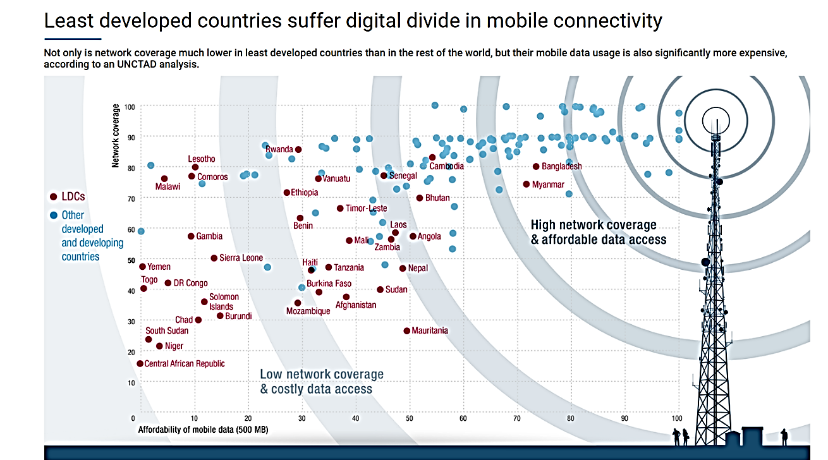

Figure 3 LEDC and MEDC digital divide (source: UNCTAD)
Digital access is restricted by inadequate infrastructure, especially unstable energy, and poor internet connectivity in most LEDCs. Broad implementation of digital access is also hindered due to the costly nature of digital goods and services as the majority of the populations in LEDCs are unable to afford them. The issue is made progressively worse by individuals' inability to use available technology efficiently due to a lack of digital literacy and education. Thus, due to the lack of sufficient electrical infrastructures, unstable economic wealth, and limited education on digital literacy, it is apparent that this divide cannot be bridged easily. All these factors contribute to widening the digital gap between the LEDCs and MEDCs.
This phenomenon was only highlighted by the global pandemic (COVID-19) where most of our society turned “digital” or “online”. According to the International Monetary Fund (IMF), “acceleration in digitalization was seen as a potential silver lining to the pandemic, equipping businesses with digital technologies that could increase productivity and growth over the long term” (Jaumotte, 2023). This meant that education, economic activities, and certain services in MEDCs relied on digital connectivity to continue their function regardless of social distancing measures. Online classes adopted by schools made it possible for students to continue with their education. For this to happen, it was necessary for students and schools to be equipped with digital devices through which communication was possible. In the aspect of workplaces, the number of employers required to work from home dramatically increased. Businesses were urged to adapt to the remote employment system, which brought on investments in information and communication technology (ICT). It is evident that the digitization of social activity was what helped MEDCs maintain stability through global chaos. However, without the respective digital and technical availabilities, LEDCs were hit with a challenging situation with little to no solution. Not only was communication difficult, but proper employment and education was at risk.

Figure 4 COVID-19 and the acceleration of digitization (source: IMF)

Just as economic instability results in insufficient digitization, the digital divide equally restrains economic development. Information and communication technologies (ICTs) are essential components of the digital economy. They promote E-commerce, which can open up new possibilities in areas like worldwide trade, fostering global collaboration and employment growth in the process. Moreover, technology diplomacy is an effective vehicle for innovation and advancement on the global ground. Therefore, to assist the growth of welfare, it is essential to make sure that nations have a dependable digital infrastructure and, as a result, a strong e-commerce infrastructure. As such, strong expansion in ICT infrastructure, connection, access, and use promise development opportunities.

Figure 5 ICT penetration levels (source: ITU)

SDG 9 on industry, innovation, and infrastructure also acknowledges the significance of infrastructure and connectivity. It is urged to "significantly increase access to information and communications technology and strive to provide universal and affordable access to the Internet in least developed countries by 2020" (UN, 2016).

3. Previous Actions

1) United Nations Development Programme (UNDP)
UNDP created a Digital Strategy, which outlines the organization's development over the following three years, adjusting to a developing digital trend:
- Digital Transformation Pathway 1: looks outward at how we can use digital technologies to improve the way we work, including how we deliver, create, collaborate and advocate,
- Digital Transformation Pathway 2: internally focused, and aims to improve the quality, relevance, efficiency, and impact of UNDP´s business through better knowledge sharing and improved data usage. (UNDP, 2019)
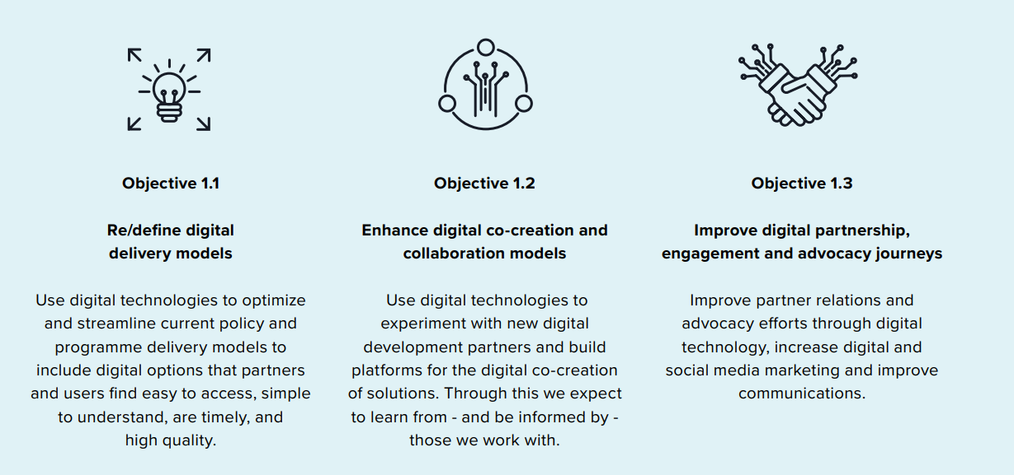
Figure 6 Digital Transformation 1 (source: UNDP)

2) United Nations (UN)
Report of the Secretary-General Roadmap for Digital Cooperation was presented by Antonio Guterres (2020). This report emphasizes the need for an inclusive digital economy and society to foster development among all countries without leaving any behind. Along with this, the human rights revolving around trust, security, and stability issues arising out of digitization are also addressed. The report also stated that the United Nations will strive to solve gaps in digitization by:
- Supporting efforts to establish a baseline of digital connectivity that individuals need to access the online space, as well as a definition of “affordability”, including universal targets and metrics;
- Convening a global group of investors and financing experts to consider the development of a financing platform and find other new models for investment in connectivity, in particular, in hard-to-reach and rural areas;
- Accelerating discussions on connectivity as part of emergency preparedness, responses and aid, including working through the inter-agency Emergency Telecommunications Cluster. (UN, 2020)

3) United Nations International Children’s Emergency Fund (UNICEF)
Giga is a global program launched in 2019 to link every school to the Internet by 2030 that was developed in partnership between UNICEF and the International Telecommunication Union (ITU). ITU's knowledge of rules and policies, UNICEF's competence in teaching and purchasing, and the private sector's quick adoption of ICT solutions have been integrated in Giga. It is a component of the ITU's Telecommunication Development Bureau and UNICEF's Office of Innovation. According to Giga, more than 2,100,000 schools have been mapped and more than 5,561 schools have been connected.
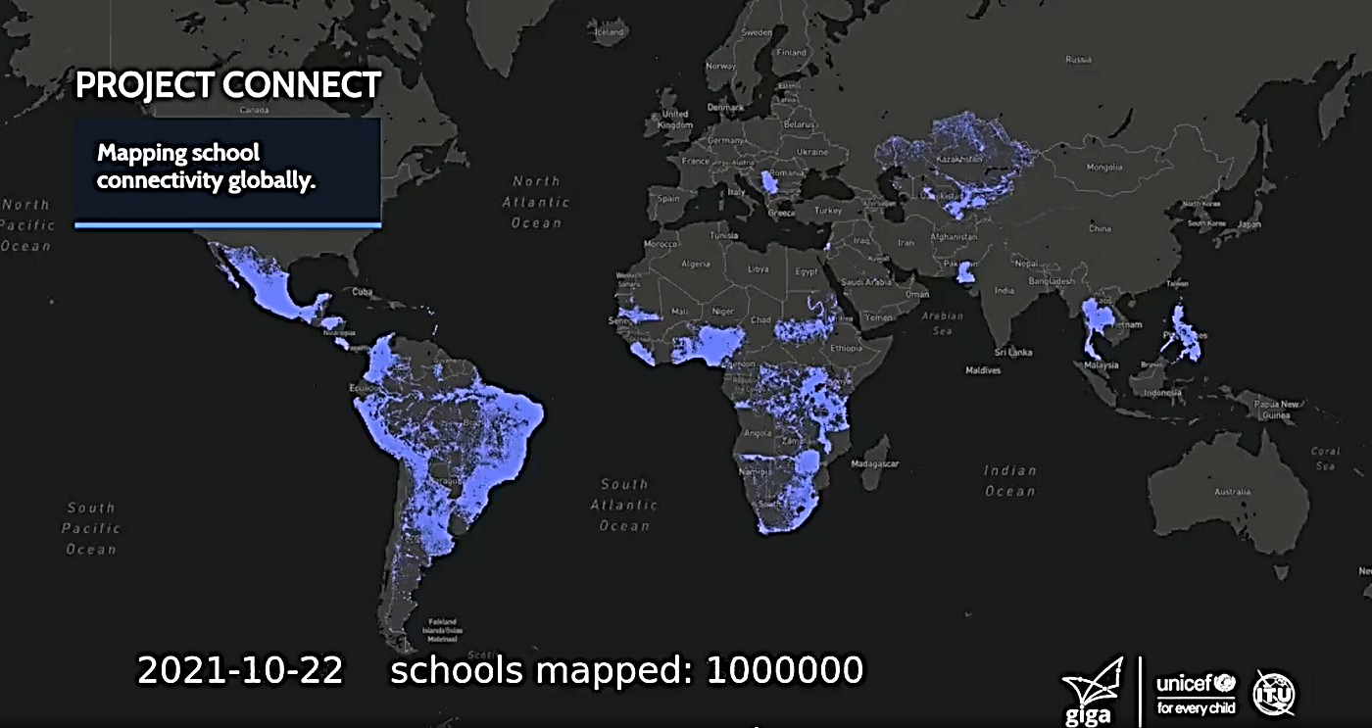

Figure 7 Visualization of One Million Schools Mapped by UNICEF's Giga Initiative (source: UNICEF)
4. Possible Actions and Solutions

1) Creating a multistakeholder body
The body would be able to represent and relay policy recommendations from multiple countries and incorporate them in decision-making forums. This would contribute to a more efficient way of aligning the policies and regulations across regions that promote digital expansion in LEDCs. It would also be capable of mobilizing resources to develop digital infrastructure and overall technological development. As such, it would also play a vital role in facilitating the exchange of technological knowledge from MEDCs to LEDCs through the movement of human capital. Finally, the body would be able to monitor and evaluate the effectiveness of their progress which would help them to narrow and specify their initiatives.

2) Education of digital literacy
Even if access to the digital world increases with the efforts of the global and national community, it would be of no use if factions of the LEDC population were digitally illiterate. Thus, governmental organizations should strive to implement digital education in schools to ensure that students can approach devices or the media with ease. Aside from schools, there should also be efforts made to educate the adult and elderly population by setting up “digital schools” or other easily accessible lessons to develop digital literacy. Having the majority of the population able to use technology effectively would also aid in the country’s technological development in the long term.

3) Incentives to attract technology companies into LEDCs
To increase job opportunities and stimulate digital and economic growth, incentives could be given to global companies in the technology industry that have branches in LEDCs. For instance, lower corporate taxes could be imposed on those branches located in LEDCs. Investment grants could also be given to companies that research and develop technology in these countries.

4) Drawing global investments and international partnerships
Aside from monetary and knowledge transfer from MEDCs to LEDCs, global investments can contribute to heightening connectivity between disparate regions, promoting collaboration, and expanding markets. This connectivity can become a driving force toward global economic integration, which would increase the exchange of goods, information, and capital. With rising economic and financial stability, capital can then be invested into developing the insufficient digital access.

5) Policies promising digital inclusivity
LEDCs have been excluded or very poorly represented in most forums regarding the development of Artificial Intelligence (AI), even though involvement itself could greatly benefit these countries in access to information. Therefore, harsher policies that guarantee LEDC’s inclusivity in forums discussing technological advancements would be ideal for the growth of these countries.

5. Defining of Key Words

1) Less Economically Developed Countries (LEDC)
Less economically developed countries are countries that struggle with serious structural barriers to sustainable development. They have low levels of human assets and are extremely susceptible to environmental and economic shocks. The Committee for Development (CDP) reviews the list of these countries every three years, which presently includes 46 nations. They are primarily in Asia, Africa, and parts of Latin America. (United Nations, n.d.)

2) More Economically Developed Countries (MEDC)
More economically developed countries are countries with robust economies where the majority of people live comfortably. This implies that people have access to quality education, medical treatment, and job possibilities. Due to their increased expenditures in technology, fixed-broadband, and infrastructure, MEDCs often have better access to digital devices than LEDCs.

3) Digital Divide
Digital divide refers to the gap between regions that have access to modern information and communications technology and those that don’t. Though the term now encompasses the technical and financial ability to utilize available technology—along with access (or a lack of access) to the internet—the gap it refers to is constantly shifting with the development of technology. (Investopedia, 2023)

4) Information and Communications Technology (ICT)
Information and communications technology is defined as a diverse set of technological tools and resources used to transmit, store, create, share or exchange information. These technological tools and resources include computers, the Internet (websites, blogs and emails), live broadcasting technologies (radio, television and webcasting), recorded broadcasting technologies (podcasting, audio and video players, and storage devices) and telephony. (UNESCO, 2020)

5) Digital Infrastructure
Digital infrastructure is the total physical and software-based infrastructure necessary to deliver digital goods, products & services. This includes data centers, fiber infrastructure, server hardware, personnel, IT virtualization & infrastructure software, operating systems, etc. (Sustainable Digital Infrastructure Alliance, 2022)

6. Key Questions

1) What is the current state of digital development in LEDCs in the aspect of;
- Mobile phone usage,
- Internet connectivity,
- Digital infrastructure,
- Possession of digital devices,
- Digital literacy rate.

2) What benefits can MEDCs obtain by contributing to the digital development of LEDCs
3) How can companies and individual businesses related to technology-based in LEDCs develop?
4) In what way can international partnerships be fostered?
5) Are there social norms in LEDCs that stigmatize the use of digital media due to the long absence of it?
6) Are there policies that currently hinder the involvement of LEDCs in technology-related forums?
7) How can data privacy and security be guaranteed along with digital development?

7. Bibliography

Giga. (n.d.). About Us. https://giga.global/about-us/

ITU. (2023). Statistics. https://www.itu.int/en/ITU-D/Statistics/Pages/stat/default.aspx.

Investopedia. (2023). The Digital Divide: What It Is, and What's Being Done to Close It. https://www.investopedia.com/the-digital-divide-5116352.

SDIA. (2022). Definition for Digital Divide. https://sdialliance.org/dictionary/digital-infrastructure/.

UN-TBLDC. (2022). LDC Insight #4: Strengthening digital capacities in the least developed countries is even more urgent in a post-COVID world. https://www.un.org/technologybank/news/ldc-insight-4-strengthening-digital-capacities-least-developed-countries-even-more-urgent-post.

UN. (2020). Report of the Secretary-General Roadmap for Digital Cooperation. https://www.un.org/en/content/digital-cooperation-roadmap/assets/pdf/Roadmap_for_Digital_Cooperation_EN.pdf.

UN. (n.d.). Least Developed Countries (LDCs). https://www.un.org/development/desa/dpad/least-developed-country-category.html.

UNDP. (2022). Can digitalization improve the well-being of nations?. https://unric.org/en/can-digitalization-improve-the-well-being-of-nations/.

UNDP. (n.d.). About Us. https://www.undp.org/about-us.

UNDP. (n.d.). What We Do. https://www.undp.org/sustainable-development-goals.

UNESCO-IIEP. (2009). Information and Communication Technologies (ICT). https://learningportal.iiep.unesco.org/en/glossary/information-and-communication-technologies-ict.

UNTACD. (2021). E-commerce and Digital Economy Programme: Bridging the Digital Readiness Divide. https://unctad.org/system/files/official-document/dtlstictinf2022d2_en.pdf.

UNTACD. (2021). Least developed countries suffer digital divide in mobile connectivity. https://unctad.org/topic/least-developed-countries/chart-april-2021.

WTO. (2017). Aid for Trade at a Glance 2017: Promoting Trade, Inclusiveness and Connectivity for Sustainable Development: Spanning the Internet Divide to Drive Development. https://www.wto.org/english/res_e/booksp_e/aid4trade17_chap5_e.pdf.

