Hanyang Model United Nations VI
Chair Report
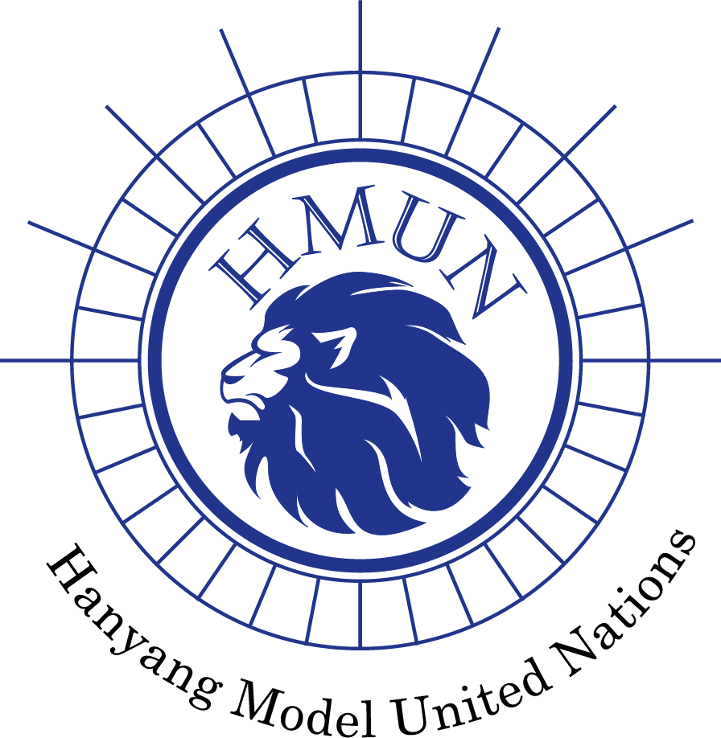
Committee: United Nations Development Programme (UNDP)
Chairs: Hwikyung Lee, Dain Kim
Agenda: Finding measures to reduce climate change impact by transitioning from a linear to a circular economy

1. Committee Introduction
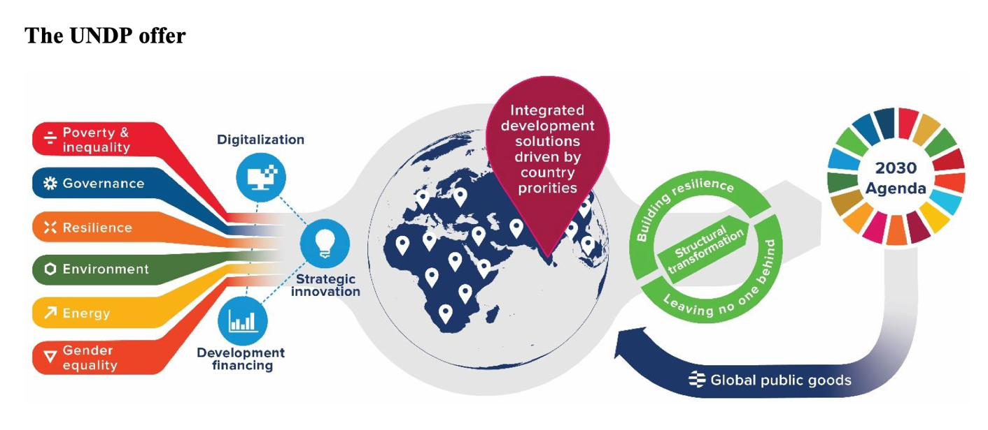
The United Nations Development Programme (UNDP) is the United Nations lead agency on international development, established to promote world development and aid for it. UNDP is based on the merging of the United Nations Expanded Programme of Technical Assistance and the United Nations Special Fund, and it was officially established in 1966 by the General Assembly of the United Nations. Its role is to provide technical advice, training, and equipment to developing countries, particularly the poorest, and it works in 170 countries and territories. It concentrated on three focus areas – sustainable development, democratic governance and peace building, and climate and disaster resilience.
Figure 1UNDP roles for reaching SDGs goals (source : UNDP)
UNDP works with governments, International Financial Institutions (IFIs), private sector companies and civil society organisations, as well as the United Nations system, to ensure that development plans achieve countries’ practical objectives.
UNDP supports countries with the strategic plans :
1) Supporting countries towards three directions of change : structural transformation, leaving no one behind, and resilience;
2) Through six signature solutions: poverty and inequality, governance, resilience, environment, energy and gender equality
3) Enhanced by three enablers: strategic innovation, digitalization, and development financing.
2. Agenda Background
The natural disasters around the world are becoming more severe. According to the World Meteorological Organisation (WMO), over the past 50 years, climate change-related disaster has occurred every day on average, resulting in an average of 115 deaths and $222 million in losses. Climate change is no longer a change but a crisis, with global average temperatures rising and weather patterns changing fast, so the entire populations are at risk of disaster. The global transition from agricultural to industrial societies and the speedy spread of it through globalization brought a rapid increase in the consumptions of natural resources. It is undeniable that with a growing population and an expanding global market, many people are looking for low-cost efficiencies, and those resulting large-scale industries are contributing to environmental pollution in many ways.

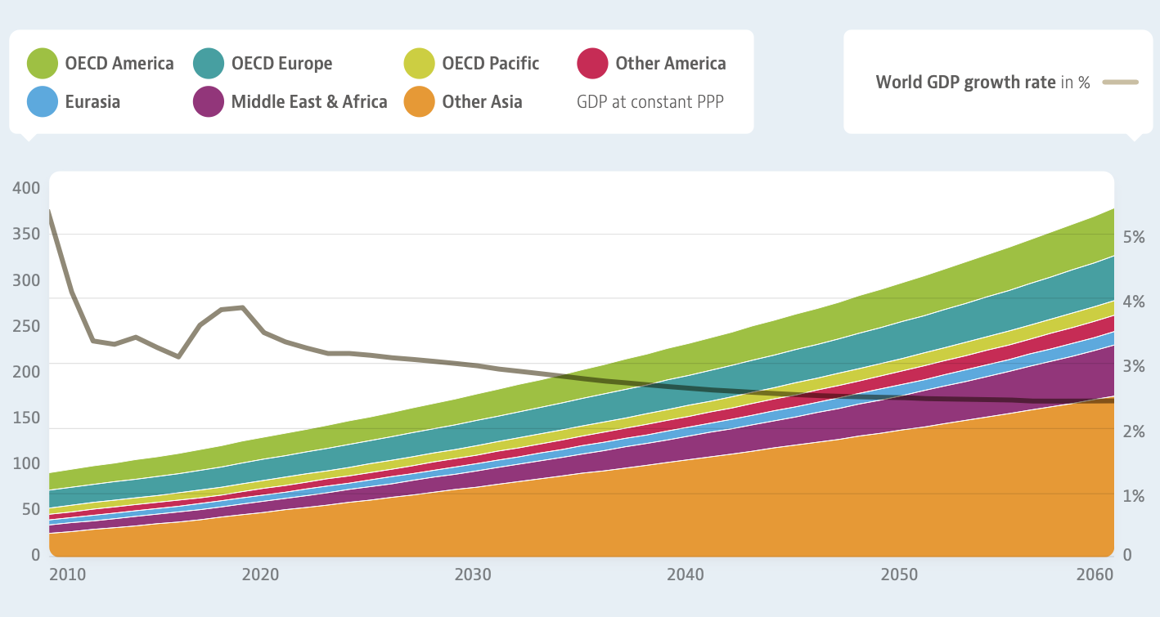
Since the 1960s, the global population has increased successive billions every one to two decades, as a result, it has doubled from 1960 to 2000. The United Nations expects to increase by nearly 2 billion persons in the next 30 years from the current 8 billion to 9.7 billion in 2050. In line with this, OECD expect that the global Gross Domestic Product (GDP) is projected to quadruple between 2011 and 2060 (figure 1).
Figure 2 Emerging economies drive the projected global GDP growth (Source: OECD)
Sustaining this population and economic growth requires a significant level of food, housing, transport, and others, all of which require immense resources. Indeed, resource extraction has grown already rapidly in the last 50 years. It reached 92 billion tons in 2017, compared with 27 billion tons in 1970. (UNEP, 2019). In the present economic system which operates linearly, material and energy from resources are consumed in one direction. The process of ‘take – make – waste’ of finite resources ends up giving rise to climate change and biodiversity loss at every stage.

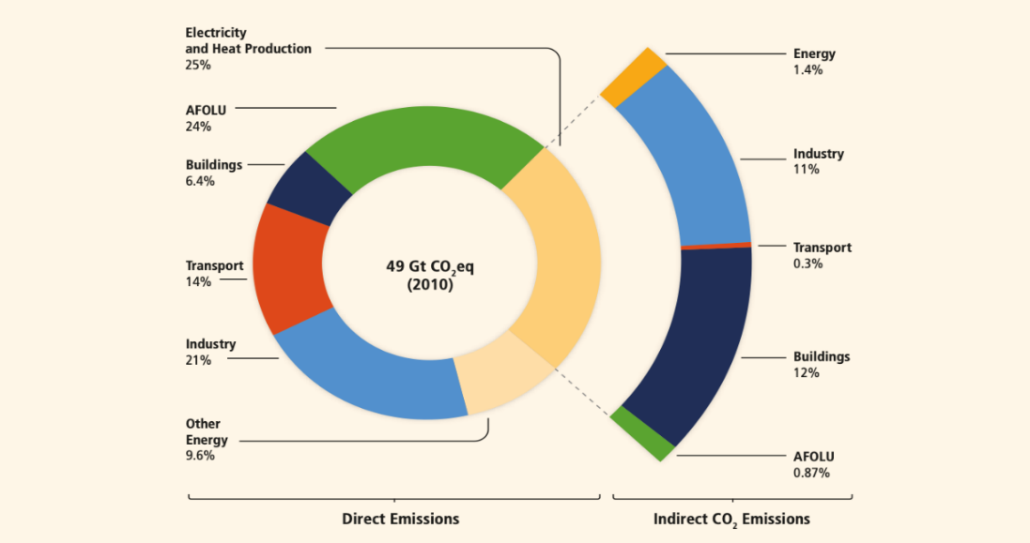
For instance, the extraction of fossil fuel which is the main resource for the energy supply not only destroys the natural ecosystem on the surface soil but also contaminates the underground and in the event of oil spills on the pipelines or ship, irreversibly pollutes the ground water and oceans. After extraction, fossil fuels are used for heating and cooking in the household, operating transports, and making products. The act of burning fossil fuels for the aforementioned purposes creates byproducts on itself, which in most cases become waste. Waste management inevitably involves incineration or landfilling, which results in Carbon Dioxide (CO2), Methane (CH4), and other greenhouse gases emissions into the atmosphere.
Figure 3. Greenhouse Gas Emissions by Economic Sectors (source : IPCC)
Forestry and agriculture activities which induce deforestation, land clearing, and degradation of soils also contribute a large proportion of CO2 emissions. Agriculture, Forestry and Other Land Use (AFOLU) sections is a part of large proportion in greenhouse gas emissions sources (figure 2). Especially after globalization, as large-scale grain companies emerged, they maximized profits by using a lot of agricultural inputs and fertilizers. Besides, they did not hesitate to destroy ecosystems and pollute the environment for the sake of mass production without considering sustainable and eco-friendly farming methods.
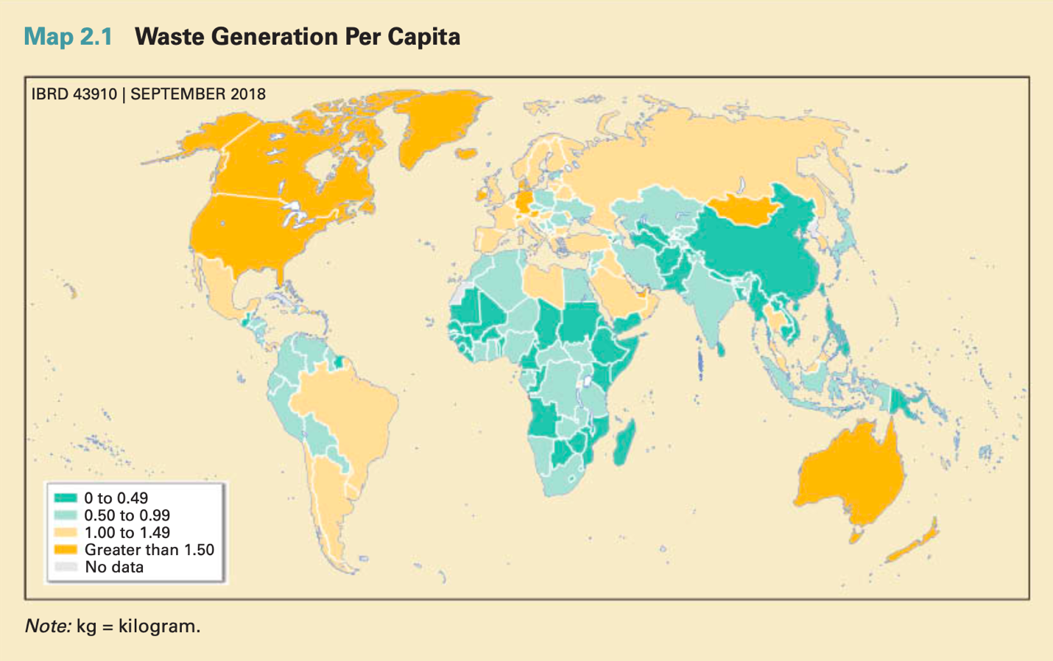
While negative externalities from AFOLU affects humankind, its impact varies significantly. The lives and health of vulnerable people, especially those in LEDCs or refugees are at greater risk mainly because of the lack of infrastructure needed for protection. The World Health Organization (WHO) diagnosed that people who contribute least to the climate crisis, and those least able to defend themselves because they are located within countries and communities that are underdeveloped and disadvantaged, are the first to be exposed to the risks of environmental pollution, growing temperature and natural disasters. The devastating flood in Libya in September 2023 illustrates how countries with poor infrastructure, such as roads and drainage, due to civil war and collapsed systems, suffer greatly.
Figure 4. Waste Generation Per Capita (source : The World Bank Group)
In the same vein, some LEDCs with virtually no environmental regulation are dumping waste indiscriminately due to a lack of waste disposal regulation and management systems, with the consequences falling on the people of those countries. For instance, the South Asia region, albeit some harbouring a large population practice open dumping in almost all cities. Some cities are “increasingly developing sanitary landfills and pursuing recycling” and “rules and regulations have been developed at national and state levels”, but “these criteria are still being translated into practice and accountability structures at the city level” (World Bank Group)
Recently, many countries have participated in negotiations to adjust their carbon emissions through the Paris Agreement and are taking big steps to manage waste. For instance, the plastic packaging tax designated by the European Union (EU) is part of the Green Deal project to limit carbon emissions starting from 2021. Some Asian countries as well have already established national strategies to address challenges related to waste management (Waste Management in Asean Countries Summary Report, 2017).
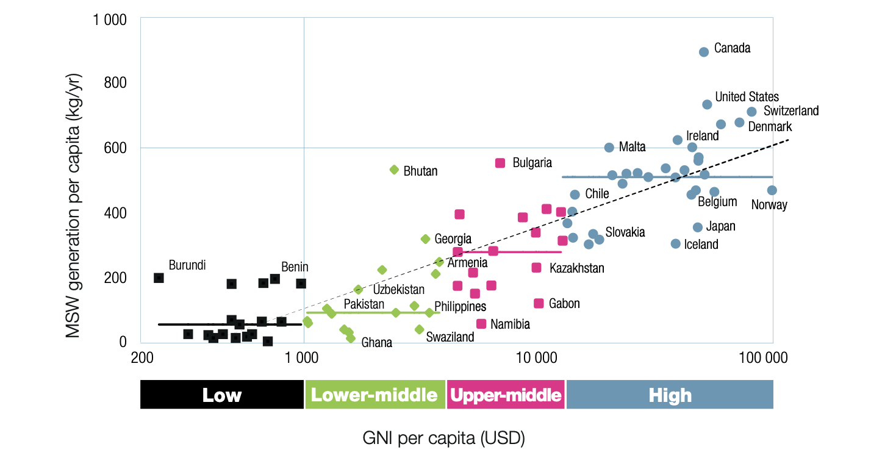
However, those kinds of current waste management policies are at the end of the linear economy system and have limited effect on fundamentally securing the circularity of resources. It can play a marginal role in slowing down or reducing the level of environmental pollution that accompanies economic growth. This is why nations must focus on a circular economy which implies “the decoupling of economic growth from the use of natural resources and inputs” at the macroeconomic level. The transition to a circular economy is essential for both LEDCs that are spurring growth, as well as high-income, MEDCs that generate large amounts of waste (figure 5). Both energy resources for industries and biological materials for agriculture require a circular approach. This will fundamentally prevent future economic growth from leading to environmental degradation. Thus, it is vital that the committee takes fundamental actions in ‘finding measures to reduce climate change impact by transitioning from a linear to a circular economy’.
Figure 5 Waste generation versus income by country (source : UNEP)

3. Previous Actions
1) United Nations Development Programme (UNDP)
The United Nations Development Programme is working with several governments and the private sector to conduct a series of assessments to identify and leverage opportunities for circular approaches across sectors such as waste, agriculture, urban planning, and construction. UNDP also contributes to the implementation of circular economy concepts by conducting strategic analyses and providing solutions to local communities, learning from case studies of circular economy approaches in countries such as Cambodia and the Philippines. For instance, UNDP implemented a circular economy project in Indonesia, where it conducted research to develop and support policy and capacity building strengthening activities among stakeholders and the development of a national Circular Economy Action Plan (CEAP).
2) United Nations Industrial Development Organization (UNIDO)
The United Nations Industrial Development Organization collaborates with government agencies and research institutes to help LEDCs build sustainable technology industries that promote achieving sustainable development goals and economic growth. Recently, UNIDO has implemented a project to support South Africa with the Council for Scientific and Industrial Research and the University Witwatersrand. This is for “transitioning from conventional plastics to more environmentally sustainable alternatives”. Organization also supports procuring laboratory equipment and testing facility to strengthen the local sustainable alternative material industry by themselves.
3) United Nations Environment Programme (UNEP)
The United Nations Environment Programme which concentrates on mainly environmental issues, organizes the seminar on World Environment Day (WED), which was established in 1972 by the UN General Assembly. Its purpose being to create a space for the sharing of innovative methods and policies for addressing plastic waste and the transition to a circular economy. It provides motivation and ideas for individuals, organizations, and governments to explore circular economy approaches. In addition, UNEP has created a circularity platform online to introduce the guidelines of the circularity model and facilitate understanding of the 4 steps of circularity building as shown below;
1) Reduce by design
2) User-to-user: Refuse, Reduce and Re-use
3) User-to-business: Repair, Refurbish, remanufacture
4) Business-to-business: Repurpose, Recycle
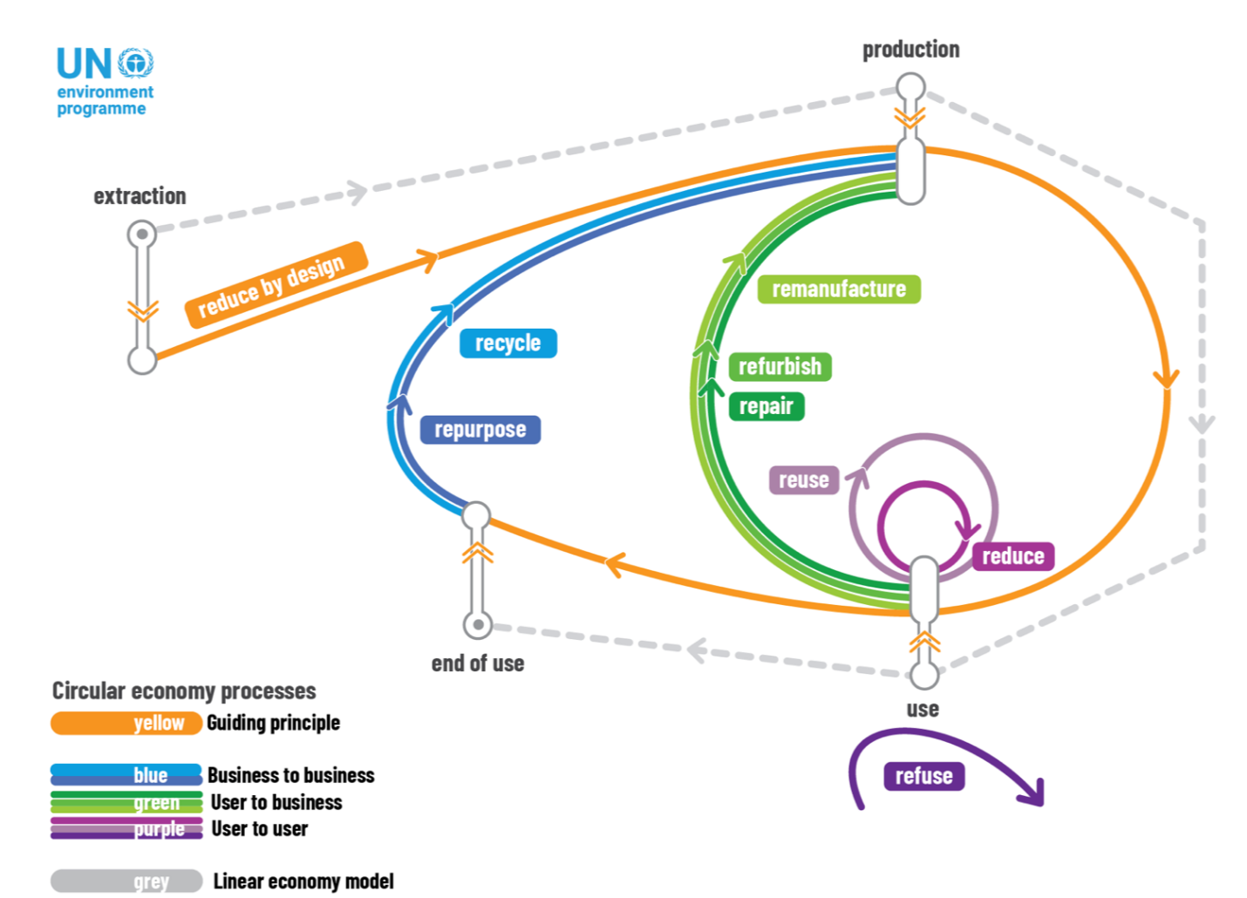
Figure 6 Circular economy system (source : UNEP)
4) International Labour Organization (ILO)
The International Labour Organization offers a range of green jobs activities, mainly through partnership agreements with governments. In May 2023, ILO published ‘Jobs in the Circular Economy’, which collects and reports on the evidence that the circular economy supports job creation. It expands research and understanding of the opportunities for a circular economy system transition in labor markets.

5) Global company and foundations
Global companies are also making the transition to circular economy systems to address environmental pollution. The Alan MacArthur Foundation, which supports networks to strengthen circular economy activities, is working with global spa brand H&M and Japan's Valuence Group on recycling initiatives. It also published a joint report with WWF and the Boston Consulting Group, "The Business Case for a UN Treaty on Plastic Pollution," calling on governments to address plastic pollution. In addition, apparel brand Patagonia not only uses recycled materials such as waste plastics to make clothing, but also strives to introduce a circular economy system in the agricultural sector by launching an organic certification programme for regenerative agriculture and engaging farmers.

4. Possible Actions and Solutions
1) Increased awareness and application of related technologies
Limited knowledge about the circular economy is the main reason why it has not yet taken hold in countries around the world. As companies have been operating using a linear economic model, a complete transformation of the system requires investment, financing, community building and training for the long term must be done. These actions are based on organized, reliable information. The UNDP, in collaboration with various research organizations, can devise ways to structure the information it collects and put it in an accessible form that takes advantage of the benefits of Industry 4.0 technologies. With the ease of creating solutions based on big data and artificial intelligence, starting the process of collecting and analyzing the data needed to transition to a circular economy and expect the effects will give the world a chance to make the successful swift.
2) Technical consultant focused on circularity
Historically, UNDP has worked in partnership with institutions and funds in a variety of sectors to provide technical assistance. With a focus on building a circular economy, the organization can play a role in working with relevant sectors to help LEDCs apply practical technologies and policies at the local level to achieve economic growth on their own. This must be accompanied by an environmental impact assessment, and technical consultancy can be carried out to help build circular systems step by step in many sectors, such as construction, vehicles, and households, to move from only focusing on waste to actually producing and recycling resources locally.
3) Expand and strengthen co-operation between countries and the private sector
Supporting for building a circular economy should not be viewed in isolation at the national or local level, but rather in a connected way, linking the enactment of laws and policies with the establishment of circular economy businesses. The disconnect between state and community often makes even well-planned policies difficult to implement. Particularly in LEDCs with less developed national systems, it may be important to look at the state of domestic economies and industries and identify opportunities to start circular economy industries through available financial resources.

5. Defining of Key Words
1) Linear Economy
Linear Economy is a model in which resources are taken, manufactured, used, and discarded as part of economic growth. This leads to unsustainable consumption of resources and energy and environmental problems.

2) Circular Economy
Circular Economy is a system that enables sustainable economic growth while protecting the environment by moving away from a linear economy. This is based on three principles – Design out waste and pollution, continued utilization of products and materials, and regeneration of natural systems. (OECD iLibrary)

3) Decoupling
Decoupling is the separation of economic growth from the consumption and disposal of resources that necessarily accompany it, so that the world can grow economically while protecting the environment, rather than polluteing the environment to grow economically.
4) Greenhouse Gases
Greenhouse Gases are gases in the atmosphere that cause the greenhouse effect. They absorb some of the infrared radiation from the sun and, in the process of re-emitting them, heat the surrounding air with energy. Therefore, the increase in greenhouse gases such as carbon dioxide (CO2) and Methane (CH4) contributes to global warming and the climate crisis.
5) Waste Management
Waste Management is the monitoring and regulation of the disposal of end-of-life resources, from incineration and landfill to recycling. Waste can include all types of results at the end of resource utilization, whether industrial, biological, or otherwise. In this case, reuse and recycling can be seen as part of building a circular economy, but the qualitative and quantitative reduction regulation of waste can be seen as a mitigating factor in a linear economy.
6) Economic Growth
Economic growth is the increase in the size of the gross domestic product over a period of time. It means a quantitative physical increase in goods and services and this can improve people’s living standards in the country. It is usually expressed as Gross Domestic Product (GDP).
7) Vulnerability
Vulnerability is the inability to resist a hazard or to respond when a disaster has occurred. (UNDRR) When a country is exposed to an unstable political situation, its people are more vulnerable and are more likely to be affected by conflict or natural disasters.

6. Key Questions
1) Why is a global shift to a circular economy important at this point?
2) What approaches should be taken to building circular economy systems in developed, developing and underdeveloped countries?
3) What are the ways in which Industry 4.0 technologies can be leveraged to bring about a circular economy?
4) What should be prioritized for the successful establishment of a circular economy?

7. Bibliography
UNDP. (n.d.). Circular Economy. https://climatepromise.undp.org/what-we-do/areas-of-work/circular-economy
UNDP. (2023). What is circular economy and why does it matter? https://climatepromise.undp.org/news-and-stories/what-is-circular-economy-and-how-it-helps-fight-climate-change
The World Bank Group. (2018). OECD What a Waste 2.0. https://datatopics.worldbank.org/what-a-waste/trends_in_solid_waste_management.html.
UN. (2023). Goal 12: Ensure sustainable consumption and production patterns https://www.un.org/sustainabledevelopment/sustainable-consumption-production
UNEP. (2015). Asia Waste Management Outlook. https://www.unep.org/resources/report/global-waste-management-outlook
UNEP. (2017). Asia Waste Management In Asean Countries Summary Report https://wedocs.unep.org/bitstream/handle/20.500.11822/21134/waste_mgt_asean_summary.pdf?sequence=1&amp%3BisAllowed=
UNEP. (n.d.). Circularity. https://www.unep.org/circularity
WHO. (2013). Global Climate Change And Health Vulnerability and Adaption Assessment. https://www.who.int/publications/i/item/9789240036383
WHO. (n.d.). How air pollution is destroying our health. https://www.who.int/news-room/spotlight/how-air-pollution-is-destroying-our-health
IPCC. (2014). Climate Change 2014: Mitigation of Climate Change. https://www.ipcc.ch/report/ar5/wg3/

UNESCO. (2023). Imminent risk of a global water crisis, warns the UN World Water Development Report 2023. https://www.unesco.org/en/articles/imminent-risk-global-water-crisis-warns-un-world-water-development-report-2023

World Economic Forum. (2017). 7 ways the Fourth Industrial Revolution can help the planet. https://www.weforum.org/agenda/2017/09/7-ways-the-fourth-industrial-revolution-can-de-stress-the-planet/
UN. (2018). World Urbanization Prospect https://population.un.org/wup/Publications/Files/WUP2018-Report.pdf
ILO. (2023). Global South circular economy could generate millions of job opportunities https://www.ilo.org/sector/news/WCMS_881334/lang--en/index.htm%20(E,F,S,R)

