Hanyang Model United Nations VI
Chair Report

Committee: World Health Organization (WHO)
Chairs: Seuyun Chang, Heeseo Kim
Agenda: Devising measures to improve prevention and response after the outbreak of zoonotic diseases
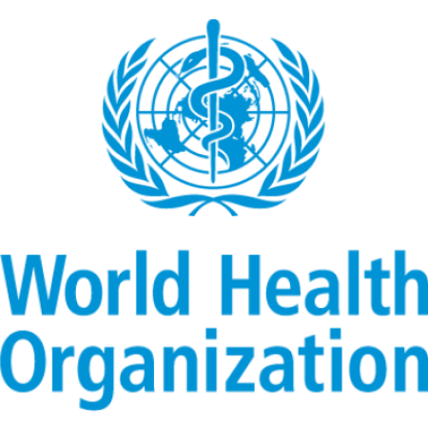
1. Committee Introduction
WHO is one of the fifteen specialized agencies of the United Nations and consists of 194 member states. The headquarters is located in Geneva, Switzerland, and its member states are organized into six regions: Africa, the Americas, Eastern Mediterranean, Europe, Southeast Asia, and Western Pacific, each with a regional office.
Following the initial formation of the United Nations in 1945, the Interim Commission temporarily supervised pre-existing health institutions for 3 years until it was dissolved on August 31, 1948. In its succession, the WHO was established on April 7, 1948 “as a specialized agency within the terms of Article 57 of the Charter of the United Nations” through the Constitution of the World Health Organization (Basic Documents 2020). The constitution promulgated the fundamental principles of human rights, universality and equity in the realm of international health.
Since its inception, the WHO has been dedicated to its mission to “promote health, keep the world safe and serve the vulnerable, with measurable impact for people at country level”, whilst upholding the core values of the United Nations, such as integrity, sustainability, and equality (World Health Organization, Our values). In order to enforce the organization's mandate of addressing international health issues and promoting global coordination within the United Nations system, the World Health Assembly convenes once a year in May. The WHA is the highest decision-making body of the WHO, where the delegates of all member states are brought together in Geneva, Switzerland to define and formulate the health policies of the organization and make critical decisions regarding global health progress such as appointing the director-general of the WHO and approving budget proposals. The annual session consists of a plenary session, the Committee on health and technical matters(A) and Committee on program, budget, and administration (B), and other technical meetings and a special committee if found necessary.
2. Agenda Background
- Background of Zoonotic diseases
The history of human civilization has evolved with animals. Dr. Jared Diamond, in his book, “Guns, Germs, and Steel”, emphasized the profound effect that livestock had brought to human civilization. First, humans could have increased agricultural production by using livestock. Second, livestock is a major source of animal protein supplied to humans. And finally, he has paid attention to the disease problem that domestication has brought about. (Deadly infectious diseases were all caused by mutant species of germs that came from livestock, such as cows and pigs.) (Measles, tuberculosis, and smallpox all originated from cattle, whooping cough or influenza originated from pigs, and AIDS as well, which is a variant of the virus caused by wild monkeys in Africa) As these animals become livestock and come in contact more with humans, germs that adapt to the human body increase. Infectious diseases that are transmitted to humans and animals together are called zoonotic disease. The pathogens that cause zoonotic infections include viruses, bacteria, prions, and parasites, and carriers also vary from arthropods (insects, spider rivers) to birds and mammals. There are various ways through which zoonotic infectious diseases are spread, such as through animals or food (hepatitis A, etc.), arthropods such as mosquitoes (malaria, etc.), experimentally spread diseases that are non-natural infections. With the SARS epidemic in 2003 and the outbreak of avian influenza human infections since 2004, most of the new infectious diseases came to be known as zoonotic diseases and the medical community as well as the public are becoming increasingly interested in them.

- Causes of emergence
Wide ranging studies on zoonotic infectious diseases have been conducted all around the world, but in recent years, various types of new infectious diseases have emerged. Both human and animal epidemics have common origins when seen from an evolutionary viewpoint, and zoonotic epidemics continue to emerge in history whenever new environments are created.
The development of an agricultural society- where people live in groups and major herbivores have been domesticated- is responsible for the emergence of zoonotic diseases. Herbivorous animals are already exposed to many infectious diseases through community life, and as humans begin to domesticate them, people frequently come in contact with them. This results in an increased contact with the associated diseases. This kind of pattern is thought to come from changes in characteristics such as mutations in pathogens, changes in human activities, and changes in the natural environment. Humans and animals share habitats due to changes in the natural environment, and global warming also increases the number of pests that spread pathogens. Phenomena such as rapid urbanization, climate change, population growth, forest development, travel liberalization and increase, international exchange of human and material resources, increased trade, industrialized social, economic development, and subsequent changes in culture are causing unprecedented infectious diseases or variants of existing infectious diseases. When the epidemic of infectious diseases begins in one region, due to the increase in exchanges between countries and liberalization of trade between them, it becomes a worldwide issue.
The emergence and prevalence of new infectious diseases has greatly affected humans and the impact of new infectious diseases on the development of human history is greater than commonly thought. The plague in Europe in the 14th and 15th centuries and the death of soldiers caused by infectious diseases are much more than the causes of death caused by wars, with bullets and arrows. Most of those infectious diseases were zoonotic diseases.
- What causes zoonotic diseases?
The World Health Organization argues that more than 25 new infectious diseases were identified in the 30 years from 1973 to 2003, most of which are zoonotic. The U.S. Centers for Disease Control and Prevention (USCDC) provides the following reasons why the new zoonotic diseases and epidemics are recently becoming more problematic.
1. Demographic changes
2. Development of medical technology and industry that enables international transmission of blood products and organ transplants
3. The logging and development of the Virgo, making people exposed to new environment and uses of new land
4. Increase in international travel and trade
5. Adaptation and change of pathogens
6. Decline in public health activities
- Examples of currently confirmed zoonotic diseases
To date, about 250 common infectious diseases are known, and about 100 infectious diseases are critical for human health and public health. For example, there are anthrax, brucella (Brucella disease), intestinal hemorrhagic E. coli infection, airborne disease (rabies), Japanese encephalitis, mutated Creutzfeldt-Jakob disease (CJD), and bovine spongiform encephalopathy (BSE), and recent new zoonotic infectious diseases which include highly pathogenic avian influenza (AI) and severe acute respiratory syndrome (SARS). Most of them threaten both humans and animals, and the management of the common infectious disease is expected to be vital since more than 75% of the recent human infectious diseases are common infectious diseases.
3. Previous Actions
- One Health Approach
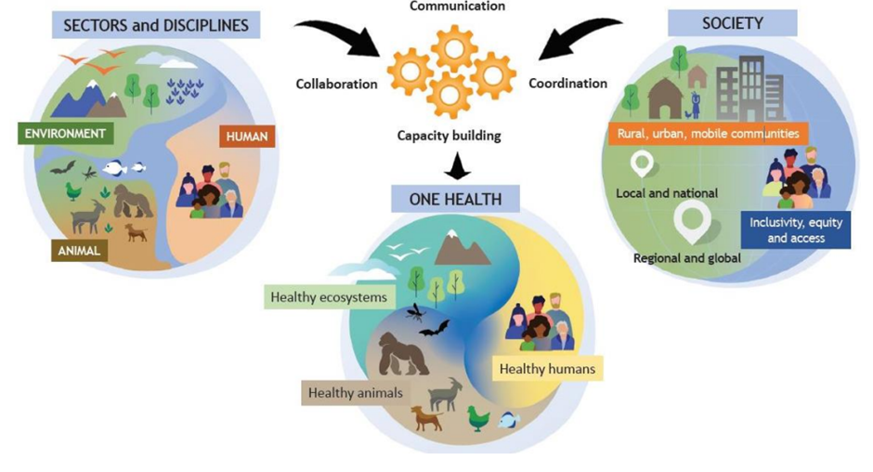(Source: WHO)
Food and Agriculture Organization of the United Nations (FAO), World Health Organization (WHO), UN Environment Program (UNEP), and World Organization for Animal Health (WOAH founded as OIE) are participating to make Quadripartite that aims to realize One Health. Their common desired purpose is to create a world which is able to prevent and predict future health problems and become better prepared for detecting and responding to health threats.
Since Action track 2 is related to zoonotic diseases, which needs more focus. Among actions track 2, there are issues such as understanding the drivers that cause the emergence of zoonotic diseases. The drivers can include pathways, ecosystem degradation, land-use and habitat change, environmental and climatic factors, as well as harvesting, farming, and trade in wild and domestic animals. Furthermore, the One Health approach tries to develop measures that can mitigate risk. This includes the maintenance of resilient healthy ecosystems, early interventions aimed at reversing or halting environmental degradation and biodiversity loss.
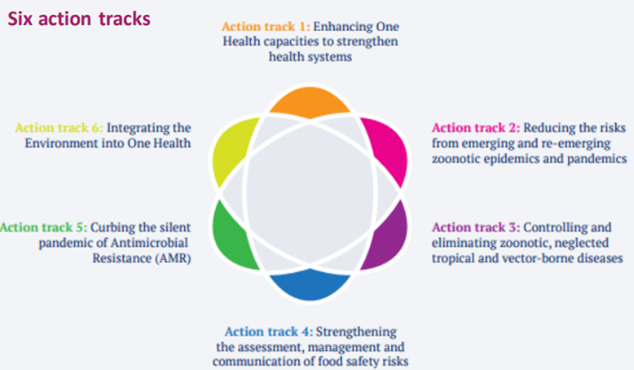
(Source: WHO)
- WHO R&D Blueprint
The World Health Organization (WHO) announced the WHO R&D Blueprint (2015) to prepare a system for rapid response to infectious diseases and reorganize regulations and policies to cope with the epidemic by revitalizing R&D.
- Inside each country (Measurement indicated inside nations)
In each country, public health measures to prevent infectious diseases should not be limited to certain regions, and research is needed to have scientific arguments for various factors that can affect the population or health of the entire environment. Not only studies on disease hosts and pathogenic factors should be conducted, but also studies on the supply status and changes of environmental factors close to life such as air, water, and soil. Based on these, policies should be promoted that consider all people, animals, and the environment in which they live.
- Current Approach and Challenges:
Currently, however, the criteria for each of these factors are set separately and policies are being decided accordingly. Therefore, policy makers need an integrated perspective that includes social and economic ideas on people, animals, pathogens, and the environment in determining major policies. As the outbreak of infectious diseases increases and spreads around the world, the response to infectious diseases is emphasized in terms of national security.
- Global Perspective on Infectious Disease Research:
This movement is growing as infectious diseases that threaten humanity continue to emerge, with more than 30 new viruses such as Middle East Respiratory Syndrome, Zika virus, and Ebola virus in the past 20 years. As explained earlier, advanced countries abroad are already conducting infectious disease research as part of One Health. According to a report by the American Society of Microbiology in 2014, the current research on infectious diseases concentrates on the human body, and the development of treatments is underway only when an outbreak occurs.
- Evolution of Research Approaches:
In the future, there will be a shift towards conducting surveillance research on animals and the environment as well as human-related infectious diseases, contrary to the paradigm of One Health. Through this, effective research to control infectious diseases will be conducted through prediction of occurrence. In order to solve the emergence of these new infectious diseases, infectious disease R&D, response to infectious diseases, and management systems need to be effectively linked and operated.
- International Cooperation and Initiatives:
In the United States, the National Institute of Allergy and Infectious Diseases (NIAID) and the Centers for Disease Control and Prevention (CDC) under the National Institute for Health are cooperating for response and management as needed. The EU operates an infectious disease R&D program, and the European Centers for Disease Control and Prevention (ECDC) has prepared a response strategy project to establish an infectious disease monitoring system by 2020. The WHO is making efforts to minimize the time to respond to new infectious diseases by forming a global network to respond to R&D.
- Increasing Research Investment:
Accordingly, research investment related to infectious diseases is continuously increasing. In fact, if you look at the trend of the acquisition of the common infectious disease budget supported by the U.S. Centers for Disease Control and Prevention in 2020, it indicates that support has nearly doubled since 2010. The groups to be managed are humans and animals, making the mismanagement of common infectious diseases differ from general infectious disease management.
- Focus on Zoonotic Infectious Diseases:
Furthermore, zoonotic infectious diseases will require management tailored to the characteristics of the disease because the infection spectrum varies, and the characteristics of each region, natural death, characteristics of mediated animals, transmission routes, and prevention methods are different for each disease.
- Global Efforts and Collaboration:
The "International Health Organization" operated by the U.S. Centers for Disease Control and Prevention has more than 40 dedicated personnel on international health issues and has dispatched more than 330 personnel to more than 60 countries, including Africa, focusing on research on the status of infectious diseases around the world. Japan is also continuously conducting research on the status of overseas infectious diseases through the "National Infectious Diseases Research Institute."
- Rapid Response and Global Fund:
The U.S. and Japan, along with seven other advanced countries (G7), have decided to create a $500 million fund to quickly dispatch medical staff internationally in the event of a pandemic of infectious diseases such as Ebola. The fund, named the Pandemic Emergency Facility (PEF), will be set up at the World Bank (WB) with the goal of reaching $500 million. The PEF is operated in the form of entrusting a certain amount of insurance money received by the World Bank from G7 countries given to private companies every year, so detailed research is expected to be conducted by region and institution. In the event of a pandemic of infectious diseases in developing countries, the World Bank plans to use the PEF insurance money to support labor costs and travel expenses from the dispatch of medical staff from the World Health Organization (WHO).

4. Possible Actions and Solutions
- Differentiated Management for Common Infectious Diseases:
The nuanced management of common infectious diseases necessitates a sophisticated understanding of the intricate interplay between human and animal populations. Tailoring strategies based on regional characteristics, mortality patterns, characteristics of intermediary hosts, transmission dynamics, and prevention methodologies is imperative to effectively mitigate the multifaceted challenges posed by these diseases.
- Identification and Neutralization of Animal Objects:
In addressing infected animals, a systematic approach involving comprehensive diagnostics, targeted culling, and group treatment modalities can be employed to purify populations. Environmental management involves stringent control measures to obstruct the ingress and dissemination of infectious agents, coupled with meticulous disinfection protocols. The meticulous identification of individual animals and rigorous tracing of their origins are paramount in curbing potential outbreaks.
- Reducing Contact Opportunities and Enhancing Host Resistance:
Strategic quarantine measures, followed by precise treatment protocols and the subsequent closure of identified clusters, constitute a proactive strategy to curtail the spread of infectious diseases. The manipulation of genetic factors to induce preventive chemotherapy tailored to specific genes offers a promising avenue for enhancing host resistance. Concurrently, the imposition of mandatory vaccination protocols serves as a robust protective measure to safeguard populations against potential outbreaks.
- Consumer Protection Strategy:
Establishing a comprehensive policy framework is essential to safeguard the integrity of the food and livestock production chain. Rigorous measures encompassing raw material management, manufacturing processes, food processing, cooking, and distribution are imperative to prevent the inadvertent introduction of harmful substances. A scientific system for the intensive management, identification, and evaluation of hygiene hazards at each stage of the production process is critical to ensure consumer safety.
- Promoting Health Practices and Health Education:
Ensuring effective communication channels between healthcare professionals and the public is pivotal. Early educational campaigns, targeted at disseminating pertinent information, coupled with active engagement initiatives involving medical personnel in both public and private healthcare institutions, play a pivotal role in fostering a culture of health consciousness. These initiatives contribute to heightened public awareness and the adoption of preventive health practices.
- Integrated Research for Holistic Policies:
A comprehensive research agenda is imperative to elucidate the intricate factors influencing population health and environmental dynamics. Beyond traditional studies on disease hosts and pathogenic factors, meticulous investigations into the status and fluctuations of environmental elements such as air quality, water composition, and soil integrity are essential. Policymakers must adopt an integrated perspective, synthesizing social and economic considerations when formulating policies that encapsulate the complex interactions between human populations, animal reservoirs, pathogens, and the environmental milieu. This approach ensures a nuanced and adaptive response to the intricate challenges posed by infectious diseases in a dynamically evolving global landscape.

5. Defining of Key Words
- Zoonotic disease:
The World Health Organization (WHO), at the expert meeting in 1952, has defined zoonotic disease as “a disease or infection that spreads naturally between vertebrates and humans.” At first, it was defined as an infectious disease in which humans and animals are infected together, but it is now generally being used as referring to diseases transmitted “from animals to people”, focused more on humans.
- One Health Approach:
One Health Approach is an integrated way that involves aims that would sustainably make an optimized balance among people, animals and ecosystems. One Health Approach acknowledges the importance of human health, domestic and wild animals, plants and a more extensive environment that includes ecosystems that are related and interdependent.
- WHO R&D Blueprint:
WHO R&D Blueprint is a global strategy and preparedness plan that allows the rapid activation of R&D activities during epidemics. Its aim is to fast-track the availability of effective tests, vaccines and medicines that can be used to save lives and avert large-scale crises..
6. Key Questions
- What policies and incentives can encourage cooperation among these sectors to prevent and respond to zoonotic diseases?
- How can we improve coordination among local, national, international organizations, governments, and NGOs to improve global governance and preparedness for zoonotic outbreaks and in responding to zoonotic outbreaks?
- Are there technologies or data sources that can be implemented to enhance detection systems for potential zoonotic disease outbreaks?
- How can we enhance communication and information-sharing during zoonotic outbreaks to prevent panic and misinformation?
7. Bibliography
Lee, K. (2023, February 13). The global governance of emerging zoonotic diseases. Council on Foreign Relations. https://www.cfr.org/report/global-governance-emerging-zoonotic-diseases
Lonescu, A. (2023, September 12). Which climatic factors promote the spread of zoonotic diseases?. Earth.com. https://www.earth.com/news/which-climatic-factors-promote-the-spread-of-zoonotic-diseases/
Olubukola Cadmus, E., Ansumana, R., Dar, O. A., & Alders , R. (2023, April 17). Infectious diseases and one health: A new research project. Devpolicy Blog from the Development Policy Centre. https://devpolicy.org/infectious-diseases-and-one-health-a-new-research-project-20230417/
RCSA, USDA Fund 7 team projects in mitigating Zoonotic Threats. National Hog Farmer. (2023, January 5). https://www.nationalhogfarmer.com/farm-policy-news/rcsa-usda-fund-7-team-projects-in-mitigating-zoonotic-threats
U.S. Government Accountability Office. (2023, May 31). Zoonotic Diseases: Federal actions needed to improve surveillance and better assess human health risks posed by Wildlife. U.S. GAO. https://www.gao.gov/products/gao-23-105238
World Economic Forum. (2023, July 6). What are Zoonotic Diseases - and how dangerous are they?. Gavi, the Vaccine Alliance. https://www.gavi.org/vaccineswork/what-are-zoonotic-diseases-and-how-dangerous-are-they
World Health Organization. (2020). Basic Documents: forty-ninth edition (including amendments adopted up to 31 May 2019). https://apps.who.int/gb/bd/pdf_files/BD_49th-en.pdf#page=1
World Health Organization. (2023, May 3). Quadripartite welcomes OHHLEP’s new White Paper on zoonotic spillover prevention. World Health Organization. https://www.who.int/news/item/03-05-2023-quadripartite-welcomes-ohhlep-s-new-white-paper-on--zoonotic-spillover-prevention
World Health Organization. (2023, May 31). Epi-win Webinar: Emerging zoonotic diseases and the One Health Approach: A Webinar Series Overview. World Health Organization. https://www.who.int/news-room/events/detail/2023/05/31/default-calendar/epi-win-webinar-emerging-zoonotic-diseases-and-the-one-health-approach
World Health Organization. (n.d.-c). Our values. World Health Organization. https://www.who.int/about/values

